# Q1 to Q12 have only one correct answer. Choose the correct option to answer your question.

1. What is the most appropriate no. of clusters for the data points represented by the following dendrogram:

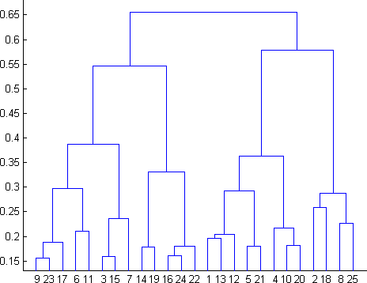

* 1. 2
  2. 4
  3. 6
  4. 8

Answer: Option b i.e. 4

1. In which of the following cases will K-Means clustering fail to give good results?
2. Data points with outliers
3. Data points with different densities
4. Data points with round shapes
5. Data points with non-convex shapes Options:
6. 1 and 2
7. 2 and 3
8. 2 and 4
9. 1, 2 and 4

Answer: b

1. The most important part of is selecting the variables on which clustering is based.
   1. interpreting and profiling clusters
   2. selecting a clustering procedure
   3. assessing the validity of clustering
   4. formulating the clustering problem

Answer: d

1. The most commonly used measure of similarity is the or its square.
   1. Euclidean distance
   2. city-block distance
   3. Chebyshev’s distance
   4. Manhattan distance

Answer: a

1. is a clustering procedure where all objects start out in one giant cluster. Clusters are formed by dividing this cluster into smaller and smaller clusters.
   1. Non-hierarchical clustering
   2. Divisive clustering
   3. Agglomerative clustering
   4. K-means clustering

Answer: b

1. Which of the following is required by K-means clustering?
   1. Defined distance metric
   2. Number of clusters
   3. Initial guess as to cluster centroids
   4. All answers are correct

Answer: d

1. The goal of clustering is to-
   1. Divide the data points into groups
   2. Classify the data point into different classes
   3. Predict the output values of input data points
   4. All of the above

Answer: a

1. Clustering is a-
   1. Supervised learning
   2. Unsupervised learning
   3. Reinforcement learning
   4. None

Answer: b

1. Which of the following clustering algorithms suffers from the problem of convergence at local optima?
   1. K- Means clustering
   2. Hierarchical clustering
   3. Diverse clustering
   4. All of the above

Answer: a

1. Which version of the clustering algorithm is most sensitive to outliers?
   1. K-means clustering algorithm
   2. K-modes clustering algorithm
   3. K-medians clustering algorithm
   4. None

Answer: a

1. Which of the following is a bad characteristic of a dataset for clustering analysis-
   1. Data points with outliers
   2. Data points with different densities
   3. Data points with non-convex shapes
   4. All of the above

Answer: d

1. For clustering, we do not require-
   1. Labeled data
   2. Unlabeled data
   3. Numerical data
   4. Categorical data

Answer: a

# Q13 to Q15 are subjective answers type questions, Answers them in their own words briefly.

1. How is cluster analysis calculated?

Answer:

1. How is cluster quality measured?
2. What is cluster analysis and its types?